
Press release no. 6
THE ECOMONDO 2024 LAYOUT
Renewed and extended with two new halls at the East Entrance

Rimini, 29th October 2024 – For its 24th edition (Rimini Expo Centre, 5th – 8th November) Ecomondo will be introducing a renewed and extended layout, reflecting the growing importance of the ecological transition and circular economy.
Italian Exhibition Group’s show will cover a total 166,000 square metres of exhibition space with a significant expansion compared to previous editions, which will include two new halls at the East Entrance in response to growing demand from sector companies. This expansion will lead to a greater number of exhibitors and offer visitors an even more complete and diversified experience.
The layout has been designed to give visitors an effective view of the content, which will be subdivided into macro-clusters that reflect the main thematic areas of the Green Economy. With this arrangement, participants will be able to find their way around the various sections more easily, thus optimising their exhibition route and enabling the encounter between demand and supply in the sustainability sector.
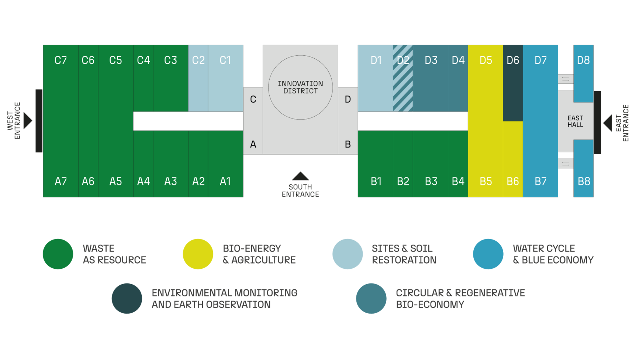
The Innovation Arena, located under the dome in the South Hall, will still be the innovation hub, hosting institutions, research centres and companies at the forefront of the green transition. This area includes spaces for start-ups, scale-ups and the Green Jobs & Skills project, which promotes the encounter between young talent and sector companies and promotes the development of new green skills.
The halls in the West area (A1-A7, B1-B4, C3-C7) will still host the Waste as Resource sector, confirming the centrality of this area, which will account for about 60% of the event. In this section, visitors will be able to explore the latest innovations in the field of waste management, waste collection, recycling and circular economy models.
In the East Area, Halls B5 and D5 will feature the Bio-Energy & Agriculture sector, where the latest innovations in bio-based renewable energy and sustainable agriculture will be presented. Halls D2-D4, on the other hand, will be dedicated to the Circular & Regenerative Bio-economy, focusing on solutions for a circular and regenerative bio-economy.
One of the main new features of the 2024 edition is the expansion of the Water Cycle & Blue Economy sector, which will occupy the new halls (D8 and B8) at the East Entrance in addition to Halls B6, B7 and D7. In this area, visitors will be able to learn more about topics related to sustainable water management, water purification, waterworks and innovative technologies for the blue economy.
Hall D6 will continue to host the Environmental Monitoring & Control area, where the most advanced technologies for environmental monitoring and control will be presented. Halls C1, C2 and D1 will accommodate Site & Soil Restoration, which will focus on remediation and regeneration techniques for contaminated soils.
Ecomondo 2024 will also be introducing new thematic spaces. In Hall C4, an area on the “Circular and Healthy City” will explore topics such as biomaterials for construction, urban health and sustainable resource management in cities, offering an integrated vision of the city of the future. In Hall C6, a new conference room will focus on trenchless (no-dig) technologies, innovative solutions for installing and maintaining underground infrastructure without resorting to open excavation, thus reducing the environmental impact.
The thematic districts introduced in previous editions are confirmed and will be further enhanced.
The Textile District, in Hall B3, makes Ecomondo a reference point for ethical fashion by presenting the latest innovations in sustainable textiles and circular economy in the textile sector. The Paper District, located in Hall B2, will gather together all the players in the paper supply chain, promoting sustainable solutions for paper production and recycling.
A significant new addition is the renovated East Hall, which will serve as a central hub for the water sector with a specific space for utilities, a new stage for events and areas for start-ups. This space will be a meeting and exchange point for all water industry players, thus fostering networking and the sharing of knowledge.

ABOUT ECOMONDO 2024
Event: International trade show; Organiser: Italian Exhibition Group S.p.A.; Frequency: annual; Edition: 27th; Dates: 5-8 November; mail: ecomondo@iegexpo.it; Website: www.ecomondo.com;
Facebook: www.facebook.com/EcomondoRimini; Twitter: http://twitter.com/Ecomondo;
LinkedIn: https://www.linkedin.com/company/ecomondo-the-green-technologies-expo/
PRESS CONTACT - ITALIAN EXHIBITION GROUP
head of media & corporate communication: Elisabetta Vitali; press office manager: Marco Forcellini, Pier Francesco Bellini; international press office coordinator: Silvia Giorgi; press office coordinator: Luca Paganin; press office specialists: Nicoletta Evangelisti, Mirko Malgieri; media@iegexpo.it
MEDIA AGENCY Hill & Knowlton
Francesca De Angelis, +39 342 7460159 - francesca.deangelis@hillandknowlton.com
Valentina Corsi - +39 3270425730 - valentina.corsi@hillandknowlton.com
Alessio Ricciuto - alessio.ricciuto@hillandknowlton.com
Foreign Press - Oksana Smirnova - smirnova.consultant@hillandknowlton.com

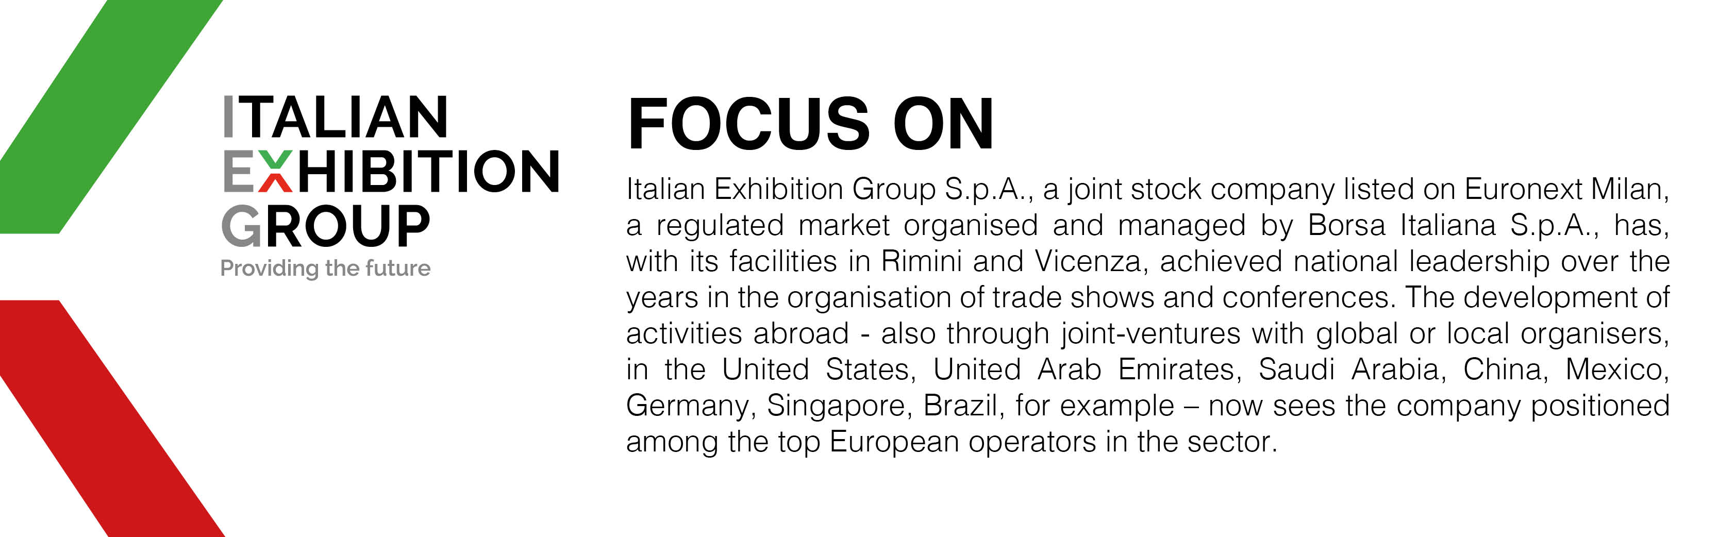

This press release contains forecast elements and estimates that reflect the management’s current opinions (“forward-looking statements”), particularly regarding future management performance, realization of investments, cash flow trends and the evolution of the financial structure. For their very nature, forward-looking statements have a component of risk and uncertainty, as they depend on the occurrence of future events. The effective results may differ (even significantly) from those announced, due to numerous factors, including, only by way of example: food service market and tourist flow trends in Italy, gold and jewellery market trends, green economy market trends; the evolution of raw material prices; general macroeconomic conditions; geopolitical factors and evolutions in the legislative framework. Moreover, the information contained in this release does not claim to be complete, and has not been verified by independent third parties. Forecasts, estimates and objectives contained herein are based on the information available to the Company as at the date of this release.

